open etc folder in Hadoop
- Right click on the file name core-site click on Edit on Notepad and add the below configuration to the file.
<configuration>
<property>
<name>fs.defaultFS</name>
<value>hdfs://localhost:9000</value>
</property>
</configuration>
- Right click on the file name hadoop-env click on Edit on Notepad and add JDK file path as show in the below:
set JAVA_HOME=C:\Java\jdk-1.8
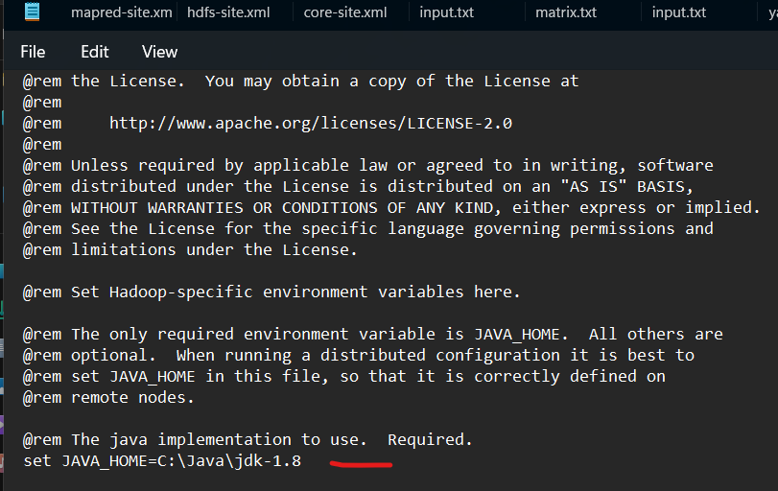
- Right click on the file name httpfs-site click on Edit on Notepad and add the below configuration to the file.
<configuration>
<property>
<name>dfs.replication</name>
<value>1</value>
</property>
<property>
<name>dfs.namenode.name.dir</name>
<value>C:\hadoop\data\namenode</value>
</property>
<property>
<name>dfs.datanome.data.dir</name>
<value>C:\hadoop\data\datanode</value>
</property>
</configuration>

- Right click on the file name hdfs-site click on Edit on Notepad and add the below configuration to the file.
<configuration>
<property>
<name>dfs.replication</name>
<value>1</value>
</property>
<property>
<name>dfs.namenode.name.dir</name>
<value>file:/C:/hadoop/data/namenode</value>
</property>
<property>
<name>dfs.datanode.data.dir</name>
<value>file:/C:/hadoop/data/datanode</value>
</property>
</configuration>
- Right click on the file name mapred-site click on Edit on Notepad and add the below configuration to the file.
<configuration>
<property>
<name>mapreduce.framework.name</name>
<value>yarn</value>
</property>
</configuration>
- Right click on the file name yarn-site click on Edit on Notepad and add the below configuration to the file.
<configuration>
<property>
<name>yarn.nodemanager.aux-services</name>
<value>mapreduce_shuffle</value>
</property>
<property>
<name>yarn.nodemanager.auxservices.mapreduce.shuffle.class</name>
<value>org.apache.mapred.shuffleHandler</value>
</property>
</configuration>

